

**North South University**

**Department of Electrical & Computer Engineering**

**LAB REPORT**

**Analog Electronics Lab**

**EEE111L**

**Experiment Number: 6**

**Experiment Name:** The BJT Biasing Circuits

**Experiment Date:** 29/11/2021

**Report Submission Date:** 7/12/2021

**Section:** 7 **Group No:** 2

**Students Name & ID:**

1. Fardin Bin Islam – 1721588642 **(Report Writer)**
2. Yusuf Abdullah Tonmoy – 1620456042
3. Md Kawser Islam – 1912296642
4. Tusher Saha Nirjhor – 1921793642
5. Md. Rifat Ahmed – 193172504

|  |  |  |
| --- | --- | --- |
| **Remarks:** | Score |  |
|  |  |
|  |  |  |
|  |  |  |

**Objectives:**

• Our objective in this experiment is to study the BJT Biasing circuits.

**Theory:**

**Biasing:** Applying DC voltages to a transistor in order to turn it on so that it can amplify AC signals. The term *biasing* is an all-inclusive term for the application of dc voltages to establish a fixed level of current and voltage. For transistor amplifiers, the resulting DC and voltage establish an *operating point* on the characteristics that define the region that will be employed for amplification of the applied signal. Because the operating point is a fixed point on the characteristics, it is also called the Quiescent point (abbreviated *Q* -point).



The biasing circuit can be designed to set the device operation at any of these points or others within the *active region.* The maximum ratings are indicated on the characteristics of the figure by a horizontal line for the maximum collector. current ICmax and a vertical line at the maximum collector-to-emitter voltage VCEmax. The maximum power constraint is defined by the curve PCmax in the same figure.

At the lower end of the scales are the cutoff region, defined by IB= 0 mA, and the saturation region, defined by VCE … VCEsat.

So, the three Operating Region are:

1. Active or Linear Region, where

* Base–Emitter junction is forward biased.
* Base–Collector junction is reverse biased.

2. Cutoff Region, where

* Base–Emitter junction is reverse biased.

3. Saturation Region, where

* Base–Emitter junction is forward biased.
* Base–Collector junction is forward biased or near forward bias.

The main objective of biasing a BJT circuit is to choose the proper **Q-point** for faithful reproduction of the input signal.

In this experiment, we will study the Fixed Bias and Self-Bias circuits.

**Fixed Bias Circuit:**

The fixed-bias circuit of the figure is the simplest transistor dc bias configuration. Even though the network employs an *NPN* transistor, the equations and calculations apply equally well to a *PNP* transistor configuration merely by changing all current directions and voltage polarities. The current directions of the figure are the *actual* current directions, and the voltages are defined by the standard double-subscript notation. For the dc analysis, the network can be isolated from the indicated ac levels by replacing the capacitors with an open-circuit equivalent because the reactance of a capacitor is a function of the applied frequency.

**Self-Bias Circuit:**

As **β** is temperature-sensitive, especially for silicon transistors, and the actual value of beta is usually not well defined, it would be desirable to develop a bias circuit that is less dependent on, or is independent of, the transistor beta. The Self-bias circuit is such a type of circuit. If analyzed on an exact basis, the sensitivity to changes in beta is quite small. If the circuit parameters are properly chosen, the resulting levels of *ICQ* and *VCEQ* can be almost independent of beta.

**Equipment List:**

• Transistor (C828/2N2222/2N3904) – 1 piece

• Transistor (BD135) – 1 piece

• Resistor (1x100kΩ, 2x10kΩ, 1x560Ω, 1x470Ω, 1x220Ω)

• Trainer Board

• DC Power Supply

• Digital Multimeter

• Cords and wires

**Circuit Diagram:**

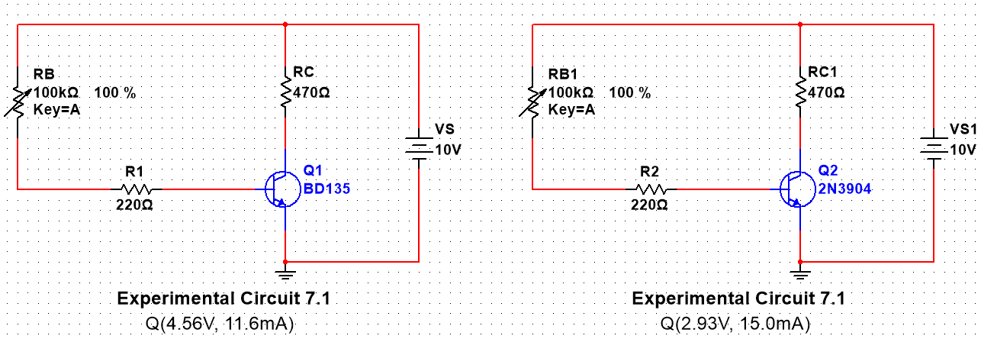

Figure 1: Fixed Bias Circuit

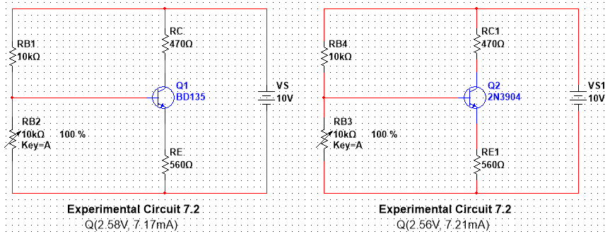

Figure 2: Self-Bias Circuit

**Data & Table:**

**Table 1:** Data for Fixed Biasing Circuit:

|  |  |  |  |
| --- | --- | --- | --- |
| **Transistor** | VCE | IC | Q(VCE, IC) |
| BD135 | 4.56V | 11.6mA | Q(4.56V, 11.6mA) |
| C828/ 2N2222 or 2N3904 | 2.93V | 15.0mA | Q(2.93V, 15.0mA) |

**Table 2:** Data for Self-Biasing Circuit:

|  |  |  |  |
| --- | --- | --- | --- |
| **Transistor** | VCE | IC | Q(VCE, IC) |
| BD135 | 2.58V | 7.17mA | Q(2.58V, 7.17mA) |
| C828/ 2N2222 or 2N3904 | 2.56V | 7.21mA | Q(2.56V, 7.21mA) |

**Result Analysis & Discussion:**

In this experiment from the two Fixed Bias Circuit and Self Bias circuit we took the Q points for two different BJT BD135 and 2N3904. We built the circuit in Multisim then simulated it to get the values of Table 1 and 2. Now if we look at the data tables, we can see that the fixed bias circuit varies a lot as both VCE & IC has quite a bit of difference for the two BJTs. However, in the voltage divider circuit we can see that the difference between the values of two BJTs are almost zero meaning that the voltage divider circuit or we could say the self-bias circuit shows better stability among the two. So, this lab was very helpful for us as we got to learn a lot about biasing circuits and now, we know which kind of biasing circuits works better. Results might’ve been a bit different if we did the actual hardware lab but overall the results would’ve been almost the same.

**Questions / Answers:**

**Answer to question 1:**

We took the Q points for two different BJT BD135 and 2N3904 in this experiment from the two Fixed Bias Circuit and Self Bias circuit. We can see from the tables that, the value of Q point for the 1st circuit is varying a lot for the two BJTs.

Now, from the first circuits data table we get,

Difference in VCE = 4.56 – 2.93 = 1.63

& the difference in IC = 15.0 – 11.6 = 3.4

On the other hand, the Q point of the 2nd circuit is almost the same using both BJTs.

Now, from the second circuits data table we get,

Difference in VCE = 2.58 – 2.56 = 0.02

& the difference in IC = 7.21 – 7.17 = 0.04

So, from these calculations it’s clear that the difference for using different BJT is a lot higher in the Fixed bias circuit whereas it’s close to zero in the self-bias circuit. So, we can say that the self-bias circuit is showing a better stability of the Q points.

**Contributions:**

|  |  |
| --- | --- |
| **Name & ID** | **Contribution** |
| Fardin Bin Islam – 1721588642  (**Report Writer)** | Data & Table |
| Yusuf Abdullah Tonmoy – 1620456042 | Theory, Equipment List |
| Md Kawser Islam – 1912296642 | Result Analysis & Discussion |
| Tusher Saha Nirjhor - 1921793642 | Circuit Diagram |
| Md. Rifat Ahmed – 1931725042 | Questions/Answers, Attachment |

**Attachment:**

**Task 01:**

Table 01 for Fixed Biasing Circuit:

|  |  |  |  |
| --- | --- | --- | --- |
| **Transistor** | VCE | IC | Q(VCE, IC) |
| BD135 | 4.56V | 11.6mA | Q(4.56V, 11.6mA) |
| C828/ 2N2222 or 2N3904 | 2.93V | 15.0mA | Q(2.93V, 15.0mA) |

Table 2 for Voltage Divider biasing Circuit:

|  |  |  |  |
| --- | --- | --- | --- |
| **Transistor** | VCE | IC | Q(VCE, IC) |
| BD135 | 2.58V | 7.17mA | Q(2.58V, 7.17mA) |
| C828/ 2N2222 or 2N3904 | 2.56V | 7.21mA | Q(2.56V, 7.21mA) |

**Task 02:**

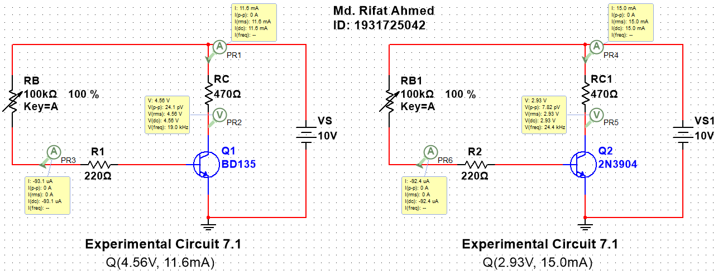

Figure 1: Fixed Bias Circuit

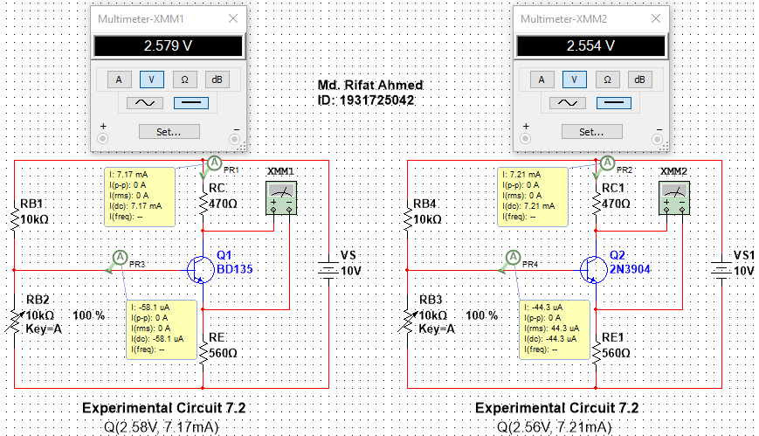

Figure 2: Self-Bias Circuit

**Task 03:**

In this experiment from the two Fixed Bias Circuit and Self Bias circuit we took the Q points for two different BJT BD135 and 2N3904. From the tables, we can see that the value of Q point for the 1st circuit is varying a lot for the two BJTs while the Q point of the 2nd circuit is almost the same. So from this experiment, we find that the self-bias circuit is showing a better stability of the Q points.

**References:**

* Storr, W. (2021, March 10). *Common Emitter Amplifier and Transistor Amplifiers*. Basic Electronics Tutorials.

<https://www.electronics-tutorials.ws/amplifier/amp_2.html>

* Wikipedia contributors. (2021, June 16). *Biasing*. Wikipedia. <https://en.wikipedia.org/wiki/Biasing>
* Transistor Biasing. <https://www.tutorialspoint.com/amplifiers/transistor_biasing.html>